**GIT Branching**

Objective: Commit HTML, CSS & JavaScript assignments into GIT.

SECTION-1 (HTML assignments) - Steps to follow:

21. First take a backup of your assignments & projects. This is required because due to incorrect GIT operation you may lose your files.

->

22. Create an empty directory ‘Assignments’ & cd to ‘Assignments’.

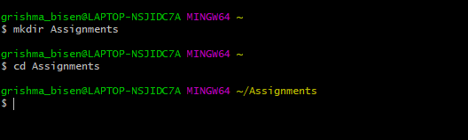

23. Create a file README.txt inside ‘Assignments’ & write few lines about the contents of ‘Assignments’ folder.

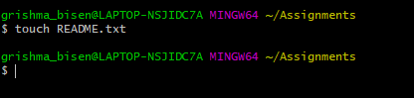

24. Commit README.txt file.

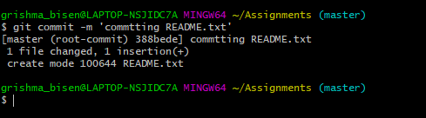

25. Now create a new branch ‘html-assignments’.

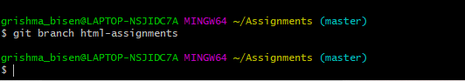

26.Switch to ‘html-assignments’ branch.

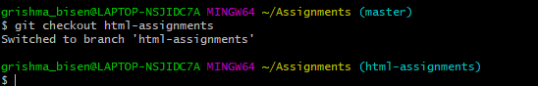

27.Copy all HTML assignments inside ‘Assignments’ folder.



28. Commit HTML assignments into ‘html-assignments’ branch.

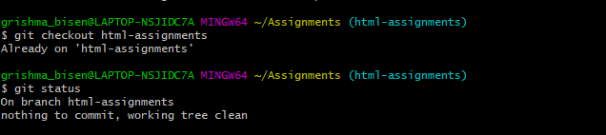

29.Make minor changes into few files belonging to ‘html-assignments’ branch

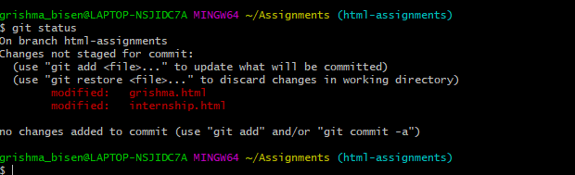

30. Commit those changed files

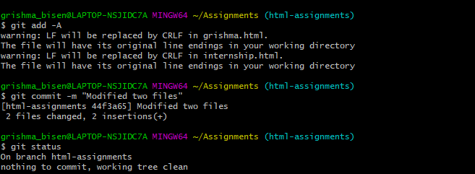

31.Switch to master branch.

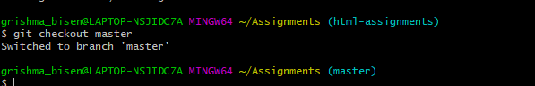

32.Make minor changes into README.txt file & commit those changes into master.

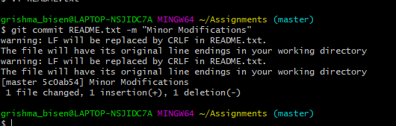

33. Again switch to ‘html-assignments’ branch.

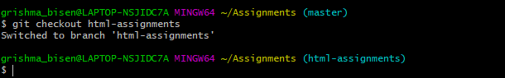

34. Make minor changes into few files belonging to ‘html-assignments’ branch.

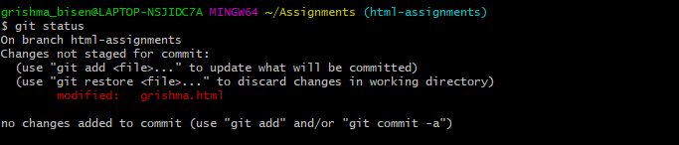

35. Commit those changes

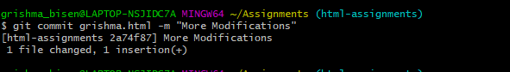

36. Switch to master.

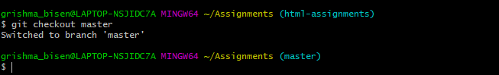

37. Merge ‘html-assignments’ branch into master. Confirm all html assignments are shown in master.

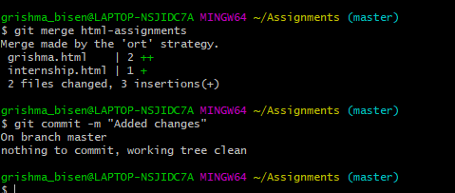

38. Finally delete the ‘html-assignments’ branch.

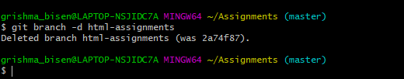

**SECTION-2 - (CSS assignments) Steps to follow:**

1. Create a new branch ‘css-assignments’.

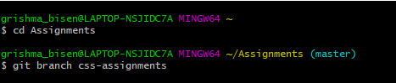

1. Switch to ‘css-assignments’ branch

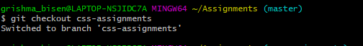

1. Copy all CSS assignments inside ‘Assignments’ folder.

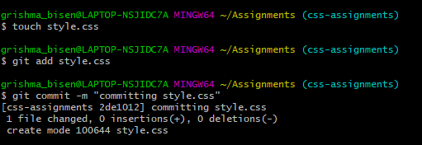

1. Commit CSS assignments into ‘css-assignments’ branch

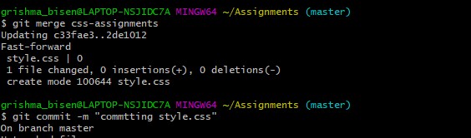

5. Make minor changes into README.txt file on line 1 belonging to ‘css-assignments’ branch

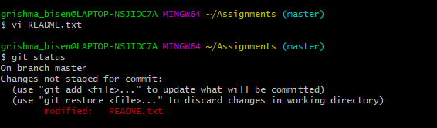

6. Commit those changed files.

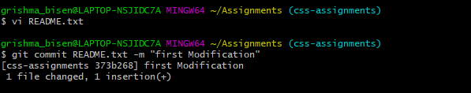

7. Switch to master branch.

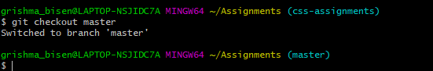

8. Make minor changes into README.txt file on line 3 & commit those changes into master

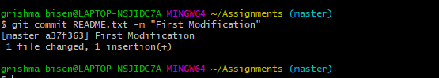

9. Again switch to ‘css-assignments’ branch.

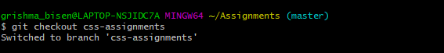

10. Make minor changes into few files belonging to ‘css-assignments’ branch

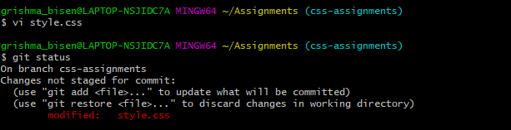

11. Commit those changes

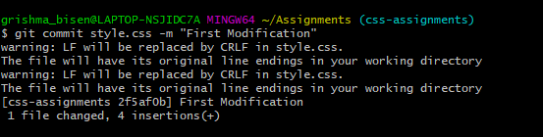

12. Switch to master

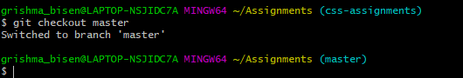

13. Merge ‘css-assignments’ branch into master. Confirm all css assignments are shown in master.

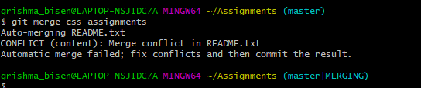

14. Finally delete the ‘css-assignments’ branch.

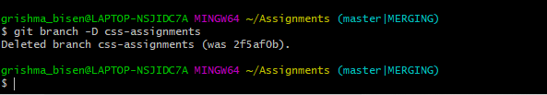

**SECTION-3 - (JavaScript assignments) Steps to follow:**

1. Create a new branch ‘js-assignments’

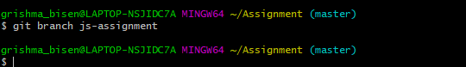

1. Switch to ‘js-assignments’ branch.

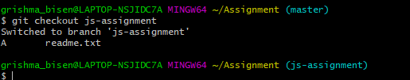

1. Copy all JavaScript assignments inside ‘Assignments’ folder

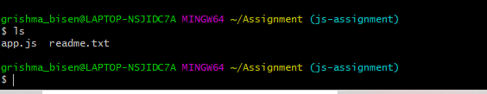

1. Commit JavaScript assignments into ‘js-assignments’ branch

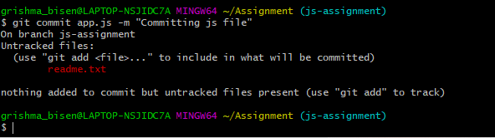

1. Make minor changes into README.txt file on line 1 belonging to ‘js-assignments’ branch

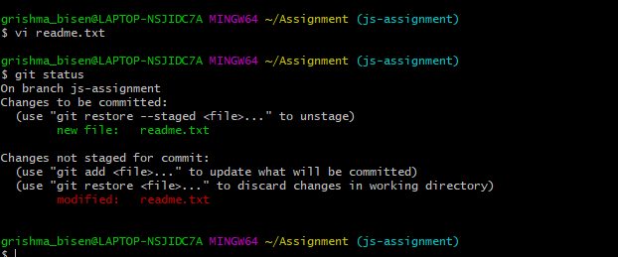

1. Commit those changed files

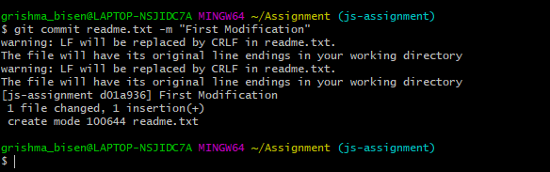

1. Switch to master branch

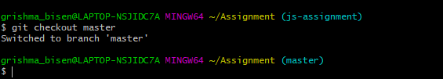

1. Make minor changes into README.txt file on line 1 & commit those changes into master.

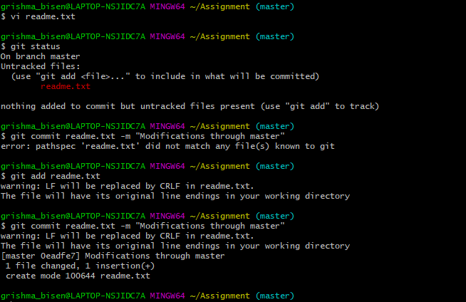

1. Again switch to ‘js-assignments’ branch.

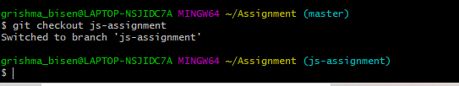

1. Make minor changes into few files belonging to ‘js-assignments’ branch
2. Commit those changes

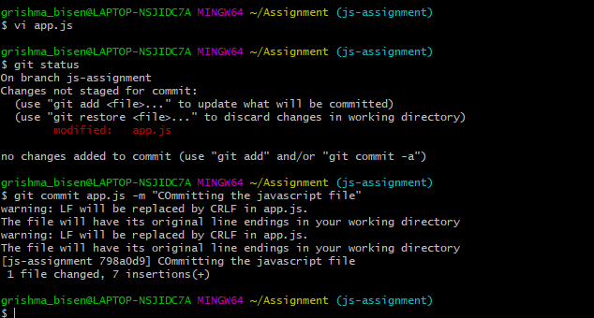

1. Switch to master

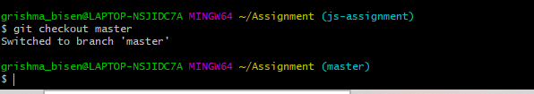

1. Merge ‘js-assignments’ branch into master. Confirm all JavaScript assignments are shown in master



1. Finally delete the ‘js-assignments’ branch.

